June 17, 2026

Welcome PreK Families!

Thank you for choosing Somerset Academy Lone Star (SALS) for your lion cub’s early childhood education. To say that we are looking forward to welcoming everyone and being your partner in your child’s education is an understatement! We are thrilled to welcome you to the 2026-2027 school year and have included important information in this communication to help make your back-to-school experience as smooth as possible.

PK School Hours. The designated PK school hours are 7:40 am- 3:10 pm. We run a morning carline drop off via the west gate, staff are stationed in front of the modular unit beginning at 7:00 am every day to welcome your cub. On August 12th, the first day of school, we welcome all PreK families to park via the east gate and walk their lion cub to class (entrance by the front office) between 7:30 am- 8:00 am and take a first day of school picture.

Calendar. PreK will follow the Lone Star’s school calendar. The 2026-2027 calendar can be found on Lone Star’s website, under resources https://somersetlonestar.org/

PK Tuition. Tuition is due for each week by 7:45 am on Monday. In order to attend class, tuition must be paid in full, and accounts must be in good standing. Parents are responsible for paying tuition when a student is absent.

Tuition Free Qualification. There are seven categories of families who might qualify for a free tuition:
Families who qualify for free/reduced lunch
Families of active-duty military servicemen and women
Families of military servicemen and women killed or injured while on active duty
Families who are considered homeless, or families in which the students are or have been in foster care at any time; and
Students who do not comprehend the English Language.
For more information about these qualifications, please contact Lone Star’s Registrar, Chantel Kling at 210-998-4452 or email at chantel.kling@somersetacademytx.org

Breakfast/Lunch. PreK students might purchase breakfast and lunch from our Cafeteria, an account should be set up prior to the first day of school. We invite you to complete the Lunch Application for our free or reduce meal program at https://linqconnect.com/main

School Uniform- PreK students will wear the Lone Star’s blue uniform polo shirt with khaki shorts, skorts or pants. All PreK students must wear tennis shoes. Lone Star’s uniform can be purchased at All Uniform Wear, uniform flyer is attached at the end of this letter.

School Supplies. School list supply is attached at the end of this letter. Each child must keep two changes of clothes in his/her cubby, and each child should bring an old shirt or smock to wear for painting. Sometimes if there is a special event – such as pumpkin math – parents might be asked to donate an item or contribute a small fee, but this is not mandatory.

Curriculum. Lone Star delivers a full PreK 4 curriculum that includes Math, Science, Social Studies and Reading. We will also feature art, music and creative play, along with daily recesses. The day will feature a mix of structured activities and free play to address the social, emotional and academic needs of each student. We follow the Texas PreK standards.

How will we measure progress? There are assessments embedded into the curriculum, which will give each student a baseline at the beginning of the year and track progress on a regular basis. The academic instructors will share this information with parents.

Are Special Education services available? Yes. Please bring your child’s most recent special education documents when you register. Based upon the documents, we may offer your child the opportunity to participate in the PPCD (Preschool Program for Children with Disabilities) program at one of our sister schools, Somerset Academy Collegiate.

Mark Your Calendar: Upcoming Events:
Meet the Teacher/Back to School Bash: Thursday, August 6th, 4 - 6 pm. Bring your school supplies, meet your child’s teacher, explore the classroom, complete After School Registration, Cafeteria account set up, and everything you will need to have a successful year. This is a very busy day so please expect to park around campus and walk to the front office.

First Day of School: Wednesday, August 12th, 2026

Thank you for choosing Somerset Academy Lone Star and investing in early childhood education. We look forward to seeing you at upcoming events. If you have any further questions, please feel free to contact Sra. Collins at 210-998-4452 or email at lily.collins@somersetacademytx.org

Respetuosamente,

Lily Collins

Lily Collins, M.Ed., M.BA.
Principal
Somerset Academy Lone Star
lily.collins@somersetacademytx.org

* 26-27 school year rate might change

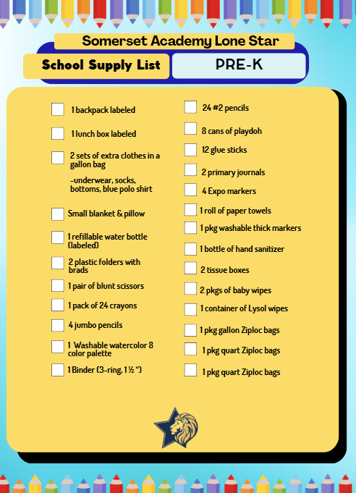

If you need help obtaining supplies, then please contact Chantel Kling: chantel.kling@somersetacademytx.org

